Laporan Praktikum 6 AMP

Antonius Aditya Rizky Wijaya

G5402221003

2025-02-27

# Linear Models and Regularization Methods

Kode halaman 268:

library(ISLR2)

## Warning: package 'ISLR2' was built under R version 4.3.3

names(Hitters)

## [1] "AtBat" "Hits" "HmRun" "Runs" "RBI" "Walks"   
## [7] "Years" "CAtBat" "CHits" "CHmRun" "CRuns" "CRBI"   
## [13] "CWalks" "League" "Division" "PutOuts" "Assists" "Errors"   
## [19] "Salary" "NewLeague"

dim(Hitters)

## [1] 322 20

sum(is.na(Hitters$Salary))

## [1] 59

Hitters <- na.omit(Hitters)  
dim(Hitters)

## [1] 263 20

sum(is.na(Hitters))

## [1] 0

Kode halaman 275

x <- model.matrix(Salary ~ ., Hitters)[, -1]  
y <- Hitters$Salary

Kode halaman 276

set.seed(1)  
train <- sample(1:nrow(x), nrow(x) / 2)  
test <- (-train)  
y.test <- y[test]

## PCR and PLS Regression

### Principal Components Regression

library(pls)

## Warning: package 'pls' was built under R version 4.3.3

##   
## Attaching package: 'pls'

## The following object is masked from 'package:stats':  
##   
## loadings

set.seed(2)  
pcr.fit <- pcr(Salary ~ ., data = Hitters, scale = TRUE,  
 validation = "CV")

summary(pcr.fit)

## Data: X dimension: 263 19   
## Y dimension: 263 1  
## Fit method: svdpc  
## Number of components considered: 19  
##   
## VALIDATION: RMSEP  
## Cross-validated using 10 random segments.  
## (Intercept) 1 comps 2 comps 3 comps 4 comps 5 comps 6 comps  
## CV 452 351.9 353.2 355.0 352.8 348.4 343.6  
## adjCV 452 351.6 352.7 354.4 352.1 347.6 342.7  
## 7 comps 8 comps 9 comps 10 comps 11 comps 12 comps 13 comps  
## CV 345.5 347.7 349.6 351.4 352.1 353.5 358.2  
## adjCV 344.7 346.7 348.5 350.1 350.7 352.0 356.5  
## 14 comps 15 comps 16 comps 17 comps 18 comps 19 comps  
## CV 349.7 349.4 339.9 341.6 339.2 339.6  
## adjCV 348.0 347.7 338.2 339.7 337.2 337.6  
##   
## TRAINING: % variance explained  
## 1 comps 2 comps 3 comps 4 comps 5 comps 6 comps 7 comps 8 comps  
## X 38.31 60.16 70.84 79.03 84.29 88.63 92.26 94.96  
## Salary 40.63 41.58 42.17 43.22 44.90 46.48 46.69 46.75  
## 9 comps 10 comps 11 comps 12 comps 13 comps 14 comps 15 comps  
## X 96.28 97.26 97.98 98.65 99.15 99.47 99.75  
## Salary 46.86 47.76 47.82 47.85 48.10 50.40 50.55  
## 16 comps 17 comps 18 comps 19 comps  
## X 99.89 99.97 99.99 100.00  
## Salary 53.01 53.85 54.61 54.61

validationplot(pcr.fit, val.type = "MSEP")

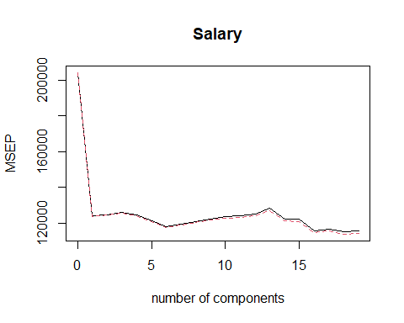

set.seed(1)  
pcr.fit <- pcr(Salary ~ ., data = Hitters, subset = train,  
 scale = TRUE, validation = "CV")  
validationplot(pcr.fit, val.type = "MSEP")

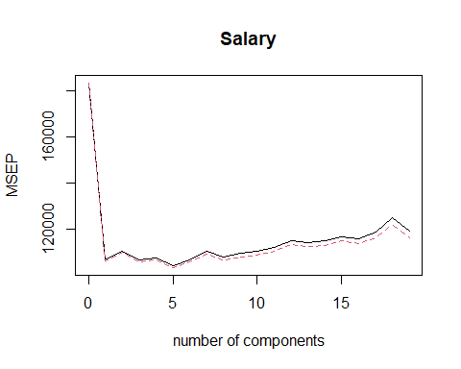

pcr.pred <- predict(pcr.fit, x[test, ], ncomp = 5)  
mean((pcr.pred - y.test)^2)

## [1] 142811.8

pcr.fit <- pcr(y ~ x, scale = TRUE, ncomp = 5)  
summary(pcr.fit)

## Data: X dimension: 263 19   
## Y dimension: 263 1  
## Fit method: svdpc  
## Number of components considered: 5  
## TRAINING: % variance explained  
## 1 comps 2 comps 3 comps 4 comps 5 comps  
## X 38.31 60.16 70.84 79.03 84.29  
## y 40.63 41.58 42.17 43.22 44.90

# Unsupervised Learning

## Principal Components Analysis

states <- row.names(USArrests)  
states

## [1] "Alabama" "Alaska" "Arizona" "Arkansas"   
## [5] "California" "Colorado" "Connecticut" "Delaware"   
## [9] "Florida" "Georgia" "Hawaii" "Idaho"   
## [13] "Illinois" "Indiana" "Iowa" "Kansas"   
## [17] "Kentucky" "Louisiana" "Maine" "Maryland"   
## [21] "Massachusetts" "Michigan" "Minnesota" "Mississippi"   
## [25] "Missouri" "Montana" "Nebraska" "Nevada"   
## [29] "New Hampshire" "New Jersey" "New Mexico" "New York"   
## [33] "North Carolina" "North Dakota" "Ohio" "Oklahoma"   
## [37] "Oregon" "Pennsylvania" "Rhode Island" "South Carolina"  
## [41] "South Dakota" "Tennessee" "Texas" "Utah"   
## [45] "Vermont" "Virginia" "Washington" "West Virginia"   
## [49] "Wisconsin" "Wyoming"

names(USArrests)

## [1] "Murder" "Assault" "UrbanPop" "Rape"

apply(USArrests, 2, mean)

## Murder Assault UrbanPop Rape   
## 7.788 170.760 65.540 21.232

apply(USArrests, 2, var)

## Murder Assault UrbanPop Rape   
## 18.97047 6945.16571 209.51878 87.72916

pr.out <- prcomp(USArrests, scale = TRUE)

names(pr.out)

## [1] "sdev" "rotation" "center" "scale" "x"

pr.out$center

## Murder Assault UrbanPop Rape   
## 7.788 170.760 65.540 21.232

pr.out$scale

## Murder Assault UrbanPop Rape   
## 4.355510 83.337661 14.474763 9.366385

pr.out$rotation

## PC1 PC2 PC3 PC4  
## Murder -0.5358995 -0.4181809 0.3412327 0.64922780  
## Assault -0.5831836 -0.1879856 0.2681484 -0.74340748  
## UrbanPop -0.2781909 0.8728062 0.3780158 0.13387773  
## Rape -0.5434321 0.1673186 -0.8177779 0.08902432

dim(pr.out$x)

## [1] 50 4

biplot(pr.out, scale = 0)

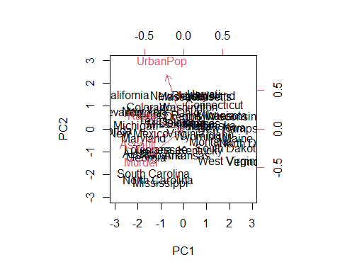

pr.out$rotation = -pr.out$rotation  
pr.out$x = -pr.out$x  
biplot(pr.out, scale = 0)

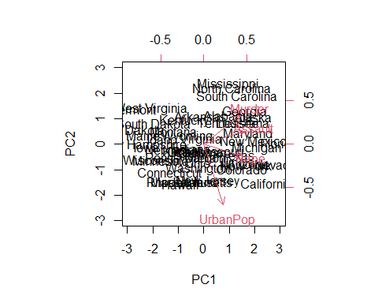

pr.out$sdev

## [1] 1.5748783 0.9948694 0.5971291 0.4164494

pr.var <- pr.out$sdev^2  
pr.var

## [1] 2.4802416 0.9897652 0.3565632 0.1734301

pve <- pr.var / sum(pr.var)  
pve

## [1] 0.62006039 0.24744129 0.08914080 0.04335752

par(mfrow = c(1, 2))  
plot(pve, xlab = "Principal Component",  
 ylab = "Proportion of Variance Explained", ylim = c(0, 1),  
 type = "b")  
plot(cumsum(pve), xlab = "Principal Component",  
 ylab = "Cumulative Proportion of Variance Explained",  
 ylim = c(0, 1), type = "b")

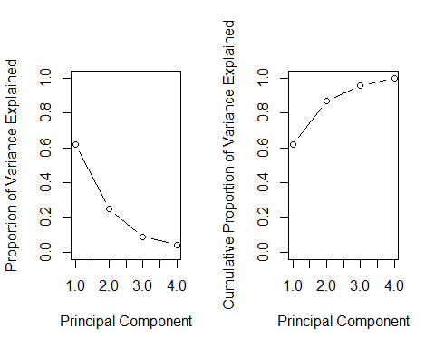

a <- c(1, 2, 8, -3)  
cumsum(a)

## [1] 1 3 11 8

## NCI60 Data Example

library(ISLR2)  
nci.labs <- NCI60$labs  
nci.data <- NCI60$data

dim(nci.data)

## [1] 64 6830

nci.labs[1:4]

## [1] "CNS" "CNS" "CNS" "RENAL"

table(nci.labs)

## nci.labs  
## BREAST CNS COLON K562A-repro K562B-repro LEUKEMIA   
## 7 5 7 1 1 6   
## MCF7A-repro MCF7D-repro MELANOMA NSCLC OVARIAN PROSTATE   
## 1 1 8 9 6 2   
## RENAL UNKNOWN   
## 9 1

### PCA on the NCI60 Data

pr.out <- prcomp(nci.data, scale = TRUE)

Cols <- function(vec) {  
 cols <- rainbow(length(unique(vec)))  
 return(cols[as.numeric(as.factor(vec))])  
 }

par(mfrow = c(1, 2))  
plot(pr.out$x[, 1:2], col = Cols(nci.labs), pch = 19,  
 xlab = "Z1", ylab = "Z2")  
plot(pr.out$x[, c(1, 3)], col = Cols(nci.labs), pch = 19,  
 xlab = "Z1", ylab = "Z3")

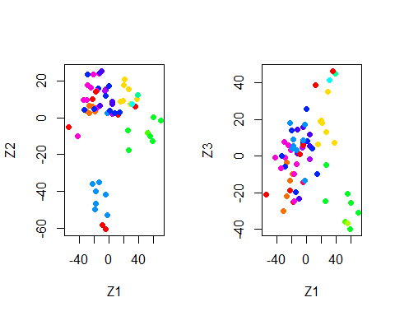

summary(pr.out)

## Importance of components:  
## PC1 PC2 PC3 PC4 PC5 PC6  
## Standard deviation 27.8535 21.48136 19.82046 17.03256 15.97181 15.72108  
## Proportion of Variance 0.1136 0.06756 0.05752 0.04248 0.03735 0.03619  
## Cumulative Proportion 0.1136 0.18115 0.23867 0.28115 0.31850 0.35468  
## PC7 PC8 PC9 PC10 PC11 PC12  
## Standard deviation 14.47145 13.54427 13.14400 12.73860 12.68672 12.15769  
## Proportion of Variance 0.03066 0.02686 0.02529 0.02376 0.02357 0.02164  
## Cumulative Proportion 0.38534 0.41220 0.43750 0.46126 0.48482 0.50646  
## PC13 PC14 PC15 PC16 PC17 PC18  
## Standard deviation 11.83019 11.62554 11.43779 11.00051 10.65666 10.48880  
## Proportion of Variance 0.02049 0.01979 0.01915 0.01772 0.01663 0.01611  
## Cumulative Proportion 0.52695 0.54674 0.56590 0.58361 0.60024 0.61635  
## PC19 PC20 PC21 PC22 PC23 PC24  
## Standard deviation 10.43518 10.3219 10.14608 10.0544 9.90265 9.64766  
## Proportion of Variance 0.01594 0.0156 0.01507 0.0148 0.01436 0.01363  
## Cumulative Proportion 0.63229 0.6479 0.66296 0.6778 0.69212 0.70575  
## PC25 PC26 PC27 PC28 PC29 PC30 PC31  
## Standard deviation 9.50764 9.33253 9.27320 9.0900 8.98117 8.75003 8.59962  
## Proportion of Variance 0.01324 0.01275 0.01259 0.0121 0.01181 0.01121 0.01083  
## Cumulative Proportion 0.71899 0.73174 0.74433 0.7564 0.76824 0.77945 0.79027  
## PC32 PC33 PC34 PC35 PC36 PC37 PC38  
## Standard deviation 8.44738 8.37305 8.21579 8.15731 7.97465 7.90446 7.82127  
## Proportion of Variance 0.01045 0.01026 0.00988 0.00974 0.00931 0.00915 0.00896  
## Cumulative Proportion 0.80072 0.81099 0.82087 0.83061 0.83992 0.84907 0.85803  
## PC39 PC40 PC41 PC42 PC43 PC44 PC45  
## Standard deviation 7.72156 7.58603 7.45619 7.3444 7.10449 7.0131 6.95839  
## Proportion of Variance 0.00873 0.00843 0.00814 0.0079 0.00739 0.0072 0.00709  
## Cumulative Proportion 0.86676 0.87518 0.88332 0.8912 0.89861 0.9058 0.91290  
## PC46 PC47 PC48 PC49 PC50 PC51 PC52  
## Standard deviation 6.8663 6.80744 6.64763 6.61607 6.40793 6.21984 6.20326  
## Proportion of Variance 0.0069 0.00678 0.00647 0.00641 0.00601 0.00566 0.00563  
## Cumulative Proportion 0.9198 0.92659 0.93306 0.93947 0.94548 0.95114 0.95678  
## PC53 PC54 PC55 PC56 PC57 PC58 PC59  
## Standard deviation 6.06706 5.91805 5.91233 5.73539 5.47261 5.2921 5.02117  
## Proportion of Variance 0.00539 0.00513 0.00512 0.00482 0.00438 0.0041 0.00369  
## Cumulative Proportion 0.96216 0.96729 0.97241 0.97723 0.98161 0.9857 0.98940  
## PC60 PC61 PC62 PC63 PC64  
## Standard deviation 4.68398 4.17567 4.08212 4.04124 1.951e-14  
## Proportion of Variance 0.00321 0.00255 0.00244 0.00239 0.000e+00  
## Cumulative Proportion 0.99262 0.99517 0.99761 1.00000 1.000e+00

plot(pr.out)

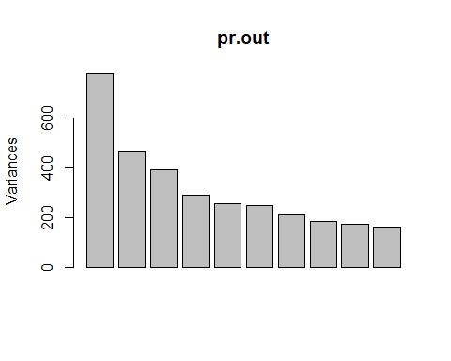

pve <- 100 * pr.out$sdev^2 / sum(pr.out$sdev^2)  
par(mfrow = c(1, 2))  
plot(pve, type = "o", ylab = "PVE",  
 xlab = "Principal Component", col = "blue")  
plot(cumsum(pve), type = "o", ylab = "Cumulative PVE",  
 xlab = "Principal Component", col = "brown3")

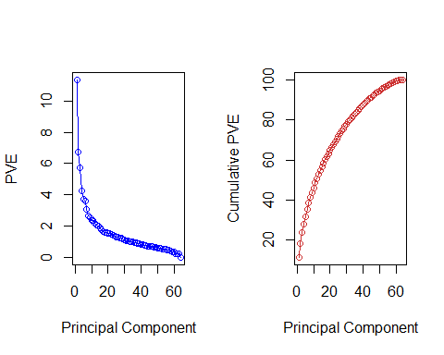

# (Subbab 6.6) Exercises Linear Models and Regularization Methods

# Nomor 9

In this exercise, we will predict the number of applications received using the other variables in the College data set.

1. Split the data set into a training set and a test set.

data("College")  
set.seed(9)  
train_index <- sample(1:nrow(College), size = 0.7 * nrow(College))  
train_data <- College[train_index, ]  
test_data <- College[-train_index, ]

1. Fit a linear model using least squares on the training set, and report the test error obtained.

lm_model <- lm(Apps ~ ., data = train_data)  
lm_predictions <- predict(lm_model, newdata = test_data)  
lm_mse <- mean((test_data$Apps - lm_predictions)^2)  
cat("Test Error (MSE) - Linear Regression:", lm_mse, "\n")

## Test Error (MSE) - Linear Regression: 1156240

1. Fit a PCR model on the training set, with $M$ chosen by cross-validation. Report the test error obtained, along with the value of $M$ selected by cross-validation.

library(pls)  
set.seed(9)  
pcr_model <- pcr(Apps ~ ., data = train_data, scale = TRUE, validation = "CV")  
summary(pcr_model)

## Data: X dimension: 543 17   
## Y dimension: 543 1  
## Fit method: svdpc  
## Number of components considered: 17  
##   
## VALIDATION: RMSEP  
## Cross-validated using 10 random segments.  
## (Intercept) 1 comps 2 comps 3 comps 4 comps 5 comps 6 comps  
## CV 3931 3914 2166 2162 1776 1709 1678  
## adjCV 3931 3914 2162 2162 1706 1697 1672  
## 7 comps 8 comps 9 comps 10 comps 11 comps 12 comps 13 comps  
## CV 1657 1644 1602 1598 1610 1614 1629  
## adjCV 1644 1634 1598 1594 1605 1609 1624  
## 14 comps 15 comps 16 comps 17 comps  
## CV 1640 1485 1226 1189  
## adjCV 1639 1465 1215 1179  
##   
## TRAINING: % variance explained  
## 1 comps 2 comps 3 comps 4 comps 5 comps 6 comps 7 comps 8 comps  
## X 32.129 57.43 64.27 69.93 75.26 80.25 83.81 87.28  
## Apps 1.879 71.08 71.14 82.47 82.49 82.93 83.77 84.15  
## 9 comps 10 comps 11 comps 12 comps 13 comps 14 comps 15 comps  
## X 90.36 92.93 95.05 96.84 97.87 98.70 99.38  
## Apps 84.74 85.13 85.13 85.19 85.20 85.21 90.65  
## 16 comps 17 comps  
## X 99.85 100.00  
## Apps 92.89 93.19

M_optimal <- which.min(pcr_model$validation$PRESS)  
cat("\nJumlah Komponen Optimal (M):", M_optimal, "\n")  
## Jumlah Komponen Optimal (M): 17

pcr_predictions <- predict(pcr_model, newdata = test_data, ncomp = M_optimal)  
pcr_mse <- mean((test_data$Apps - pcr_predictions)^2)  
cat("Test Error (MSE) - PCR:", pcr_mse, "\n")

## Test Error (MSE) - PCR: 1156240

validationplot(pcr_model, val.type = "MSEP")

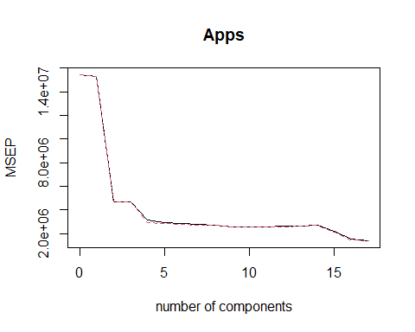

MSEP adalah error prediksi dalam Cross-Validation Karena MSEP stabil setelah M = 17, maka M optimal = 17 (menghindari overfitting)

# (Subbab 12.6) Exercises Unsupervised Learning

# Nomor 8

In Section 12.2.3, a formula for calculating PVE was given in Equation 12.10. We also saw that the PVE can be obtained using the sdev output of the prcomp() function.

On the USArrests data, calculate PVE in two ways:

1. Using the sdev output of the prcomp() function, as was done in Section 12.2.3.

data("USArrests")  
hasil_pca <- prcomp(USArrests, center = TRUE, scale. = TRUE)  
pve_a <- (hasil_pca$sdev^2) / sum(hasil_pca$sdev^2)  
cat("PVE menggunakan sdev dari prcomp():\n")

## PVE menggunakan sdev dari prcomp():

print(pve_a)

## [1] 0.62006039 0.24744129 0.08914080 0.04335752

1. By applying Equation 12.10 directly. That is, use the prcomp() function to compute the principal component loadings. Then, use those loadings in Equation 12.10 to obtain the PVE.

These two approaches should give the same results.

lambda <- apply(hasil_pca$x, 2, var)  
pve_b <- lambda / sum(lambda)  
cat("PVE menggunakan Equation 12.10:\n")

## PVE menggunakan Equation 12.10:

print(pve_b)

## PC1 PC2 PC3 PC4   
## 0.62006039 0.24744129 0.08914080 0.04335752

identical(round(unname(pve_a), 8), round(unname(pve_b), 8))

## [1] TRUE

Menggunakan sdev dari prcomp()lebih sederhana daripada menghitung secara manual dengan Equation 12.10. Kedua metode memberikan hasil yang identik, yang membuktikan keakuratan teori PCA dalam menangkap variansi data. PCA berguna untuk reduksi dimensi, karena kita dapat memilih beberapa PC pertama yang menjelaskan sebagian besar variansi, tanpa kehilangan terlalu banyak informasi.

# Nomor 10

In this problem, you will generate simulated data, and then perform PCA and $K$-means clustering on the data.

1. Generate a simulated data set with 20 observations in each of three classes (i.e. 60 observations total), and 50 variables.

set.seed(10)  
n <- 20  
p <- 50  
class1 <- matrix(rnorm(n * p, mean = 0), nrow = n, ncol = p)  
class2 <- matrix(rnorm(n * p, mean = 3), nrow = n, ncol = p)  
class3 <- matrix(rnorm(n * p, mean = -3), nrow = n, ncol = p)  
X <- rbind(class1, class2, class3)  
true_labels <- rep(1:3, each = n)

1. Perform PCA on the 60 observations and plot the first two principal component score vectors. Use a different color to indicate the observations in each of the three classes. If the three classes appear separated in this plot, then continue on to part (c). If not, then return to part (a) and modify the simulation so that there is greater separation between the three classes. Do not continue to part (c) until the three classes show at least some separation in the first two principal component score vectors.

pca_result <- prcomp(X, center = TRUE, scale. = TRUE)  
plot(pca_result$x[, 1:2], col = true_labels, pch = 19,  
 xlab = "PC1", ylab = "PC2", main = "PCA - PC1 vs PC2")  
legend("bottomleft", legend = c("Class 1", "Class 2", "Class 3"),  
 col = 1:3, pch = 19)

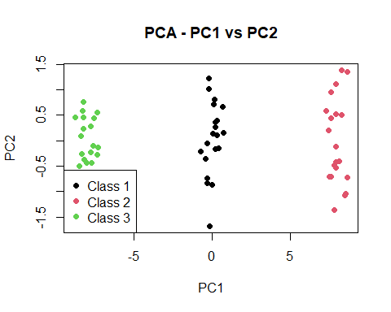

Data simulasi dibuat dengan 3 kelas (masing-masing 20 observasi) dan 50 variabel. PCA digunakan untuk melihat apakah kelas dapat dipisahkan dan ternyata berdasarkan plot kelas dapat dipisahkan.